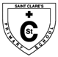
St Clare’s Primary School

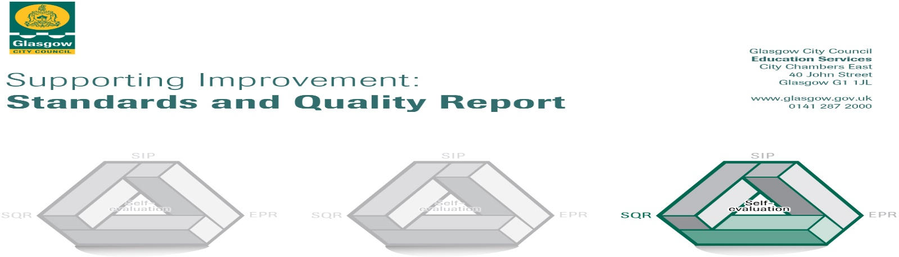

This summary report for 2017-2018 for parents/carers and partners outlines our achievements last session and our priorities for next session. We have taken forward our priorities as detailed in our school improvement plan. Through our processes of self-evaluation, we have identified how we can improve outcomes for our children, young people and families.

Our achievements and improvements this year:2017-2018
We would like to highlight the following improvements /achievements:
In celebrating the Centenary of Catholic Education in Scotland we have further reflected on our school vision, values, aims and our commitment to the characteristics of the Charter for Catholic schools. These are clearly reflected in our Catholic ethos which is promoted across our whole school community on a daily basis as well as at special times of sacramental preparation.
Our P6 pupils are now working successfully on achieving the Pope Francis Faith Award. They are being encouraged to use what they are learning about the Gifts of the Holy Spirit in their lives across school, home and parish.
Through sharing of information all staff have a clear understanding of the cultural context of the school and are responsive to supporting improvement. Pupil Equity Funding has facilitated change leading to greater equity for all our learners and families.
Our familiar and motivating school motto ‘Altogether Every Day, Partnership in Every Way’ together with use of various other strategies promotes, and has led to improved attendance. We will continue to build on this with your support.

All staff are committed to St Clare’s school improvement plan which benefits all of our pupils and families. Teachers are participating in ‘Teacher Learner Communities’ and as a result are engaging in activities which are leading to reflection, positive change and improved quality of teaching.
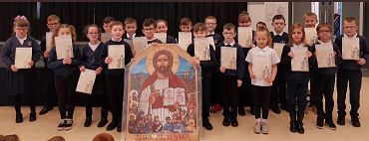This is enhancing the school culture of supporting improvement whilst building the capacity of staff.A few support members of staff have also shown interest in developing their practice and are now being trained as part of this programme too.
Raising attainment across the core areas is central to school plans for improvement.
A range of data is used to measure our young people’s performance and we use this information to plan appropriate support for all children in order to enable them to reach their full potential. Through analysing this data it is clear that most children are making progress across literacy and numeracy.
Our new maths programme Heinemann Active Maths was introduced and training for staff was provided.
The programme is supporting an increasing number of active & engaging learning experiences through games and digital technologies whilst traditional maths textbook/worksheet activities are now reducing.
Sumdog use has increased significantly both at school and at home and is effectively supporting improvement in numeracy.
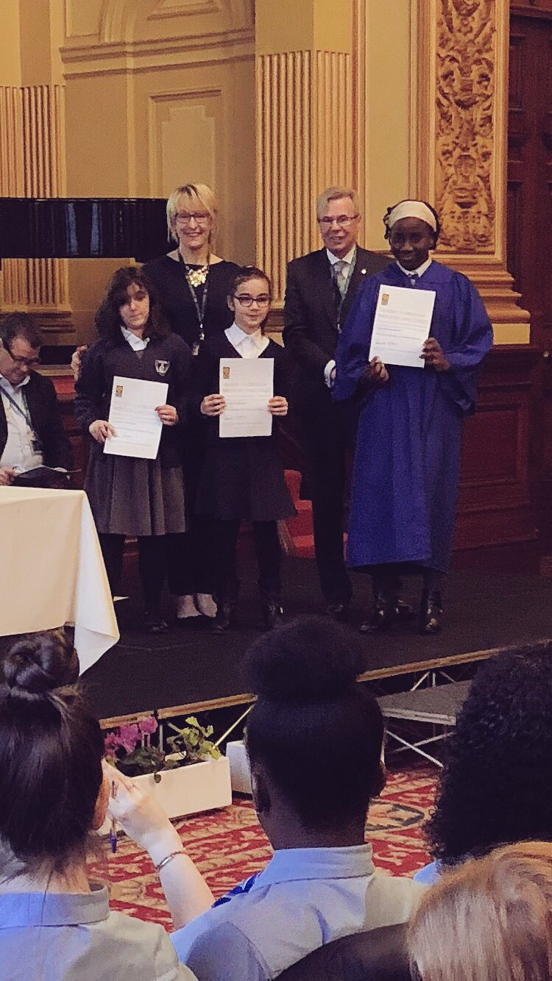
During HT visits to classes, almost all children were motivated and engaged in learning throughout numeracy lessons and activities. Class observations of learning and teaching in science led by our science coordinator evidenced that in almost all classes there were excellent scientific discussions and investigations taking place. Led by our digital leader of learning, class observations of learning and teaching within technologies evidenced high levels of engagement where learners were motivated and interested in the learning taking place and achieved success as a result. The established digital learning committee has been supporting the school’s digital learning journey. The digital leader of learning and two P7 pupils also presented their learning, sharing good practice, confidently at an event at City Chambers.
Learners across P1-P7 earned certificates for their participation in various challenges through the Primary Engineer’s Leaders’ Award. Two pupils were shortlisted for the award and their inventions were displayed at the City Chambers.
Attending City Chambers at another event were pupils from across P5 to receive well deserved language awards.

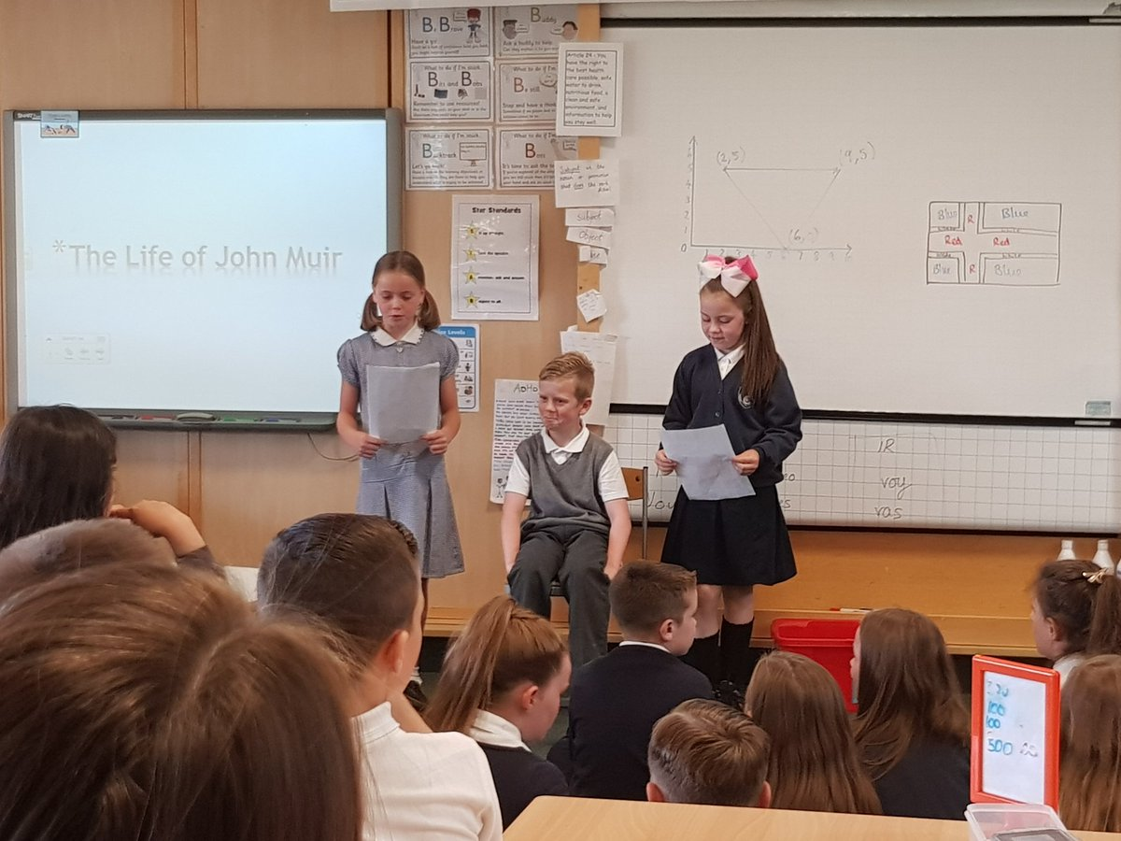
Opportunities for outdoor learning are growing across most stages. Staff and children are now increasingly engaging in outdoor learning, using the beautiful green spaces of Drumchapel for both learning and development of well-being. The outdoor clothing purchased through Pupil Equity Funding is helping children embrace our Scottish weather!
P5 successfully achieved the John Muir Award for their efforts!

Family Learning events and day trips led by our Family Learning Officer have impacted positively also on outdoor learning as a growing number of families are now attending organised events within and out with the school day.
The Family Learning programme has increased parental involvement in the life of school and this has impacted positively on attendance at other school events like ‘Meet the Teacher’ where numbers in attendance have significantly increased.
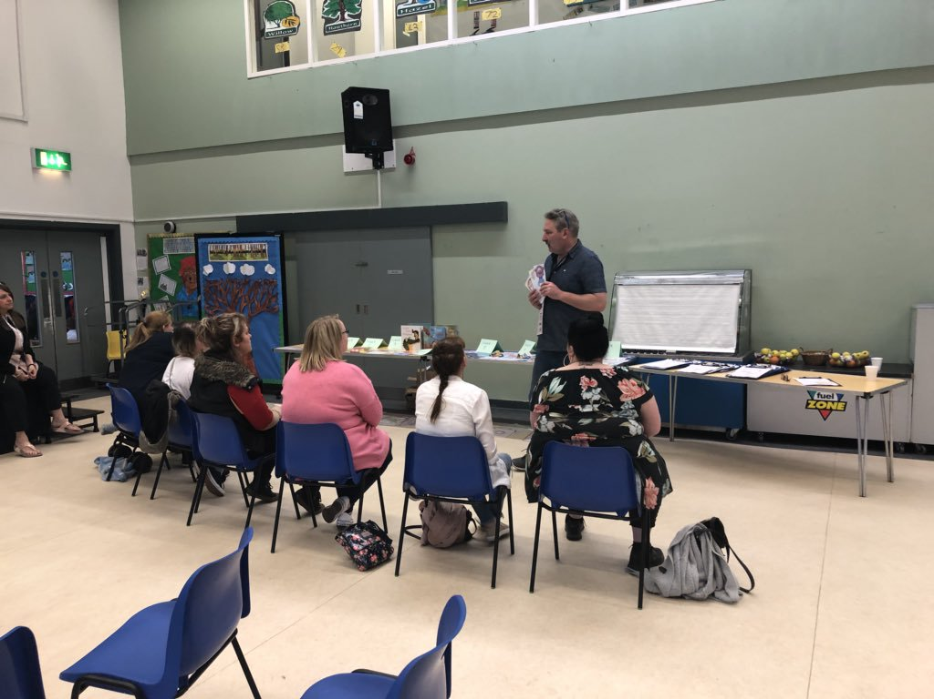
St Clare’s Parent Council continues to provide support in funding trips, school activities and gifting leavers’ presents.
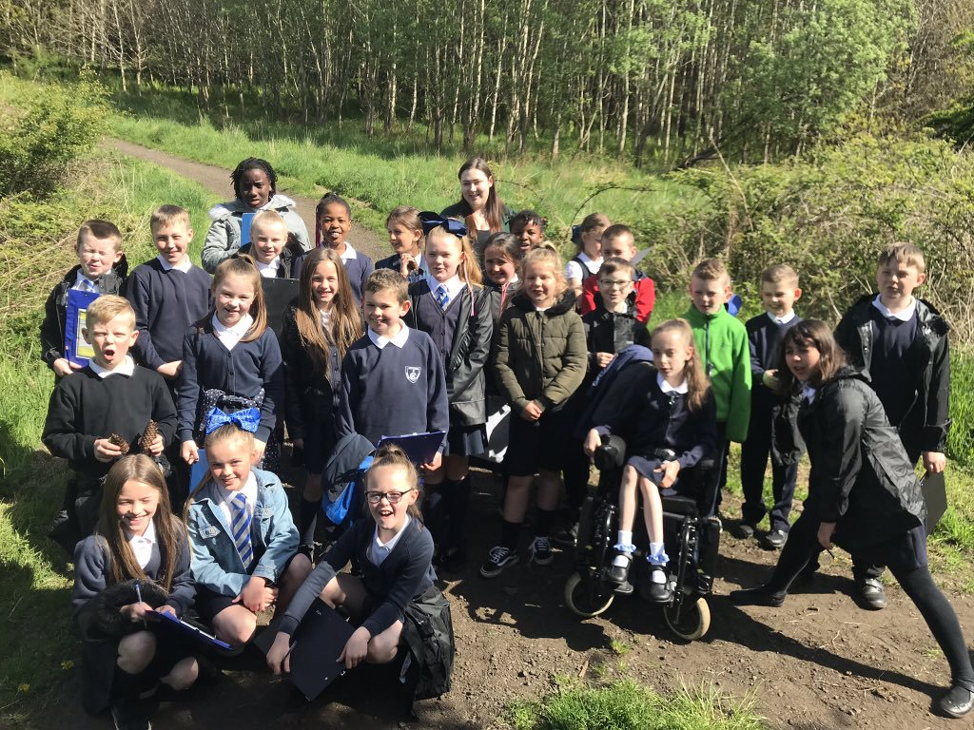
As a result of Glasgow’s Improvement Challenge and Pupil Equity Funding [PEF], additional interventions are being implemented. Together with role of partner agencies these are addressing needs of vulnerable children and families across the areas of wellbeing. Almost all partner services are having a positive impact on improving the wellbeing of almost all targeted pupils and families.
The Spark counselling sessions offers pupils a combination of therapeutic play, art therapy and talking therapy and is making a direct contribution to the health and wellbeing of pupils.
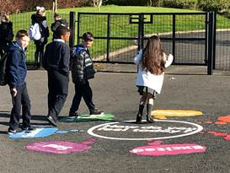
CAN I coaching parent empowerment programme supported a group of parents, working on life skills attitudes and goal setting. A small group of parents consistently attended and completed most of programme.
With the addition of game zones and playground markings the playground has been transformed providing improved areas for the children to play .Jenny Mosley visited St.Clare’s and modelled strategies/approaches to support social and emotional well-being of staff and pupils including Quality Circle Time and Positive Play/Lunch time strategies. This will support our continuing work with health & wellbeing.
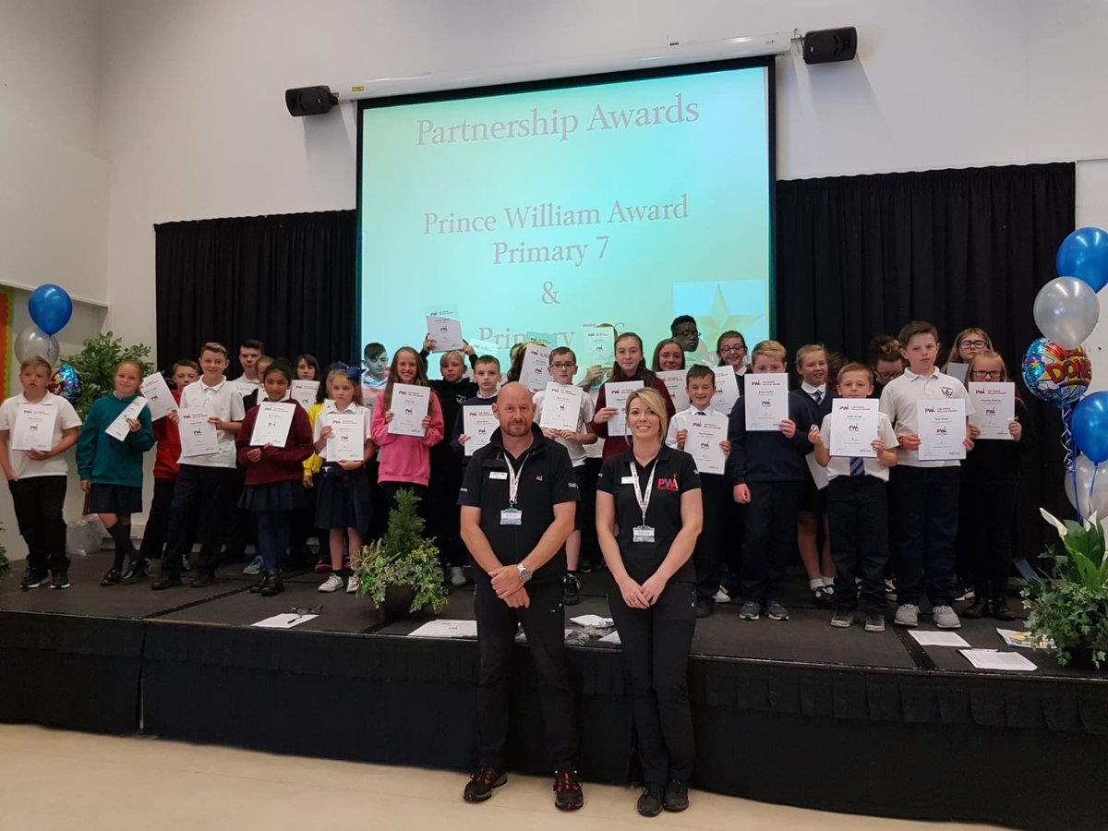
Prince William Award was achieved by all learners across P7 and P7/6 resulting in improved skills of cooperation, leadership, self-esteem across this group of learners. Almost all pupils expressed that they enjoyed this programme and are developing their skills for learning, life and work.

As part of the Glasgow Improvement Challenge our ‘Challenge Leader of Learning’ has led staff through developments in the teaching and assessment of writing and provided universal support for all pupils. Targeted support was provided across second level where specific gaps were identified and improvement was clearly made by almost all learners within the targeted group.
Most learners across P1-P7 are on track to achieving the appropriate level across core areas. Our robust tracking system enables us to ensure continuous progress for all children. We closely monitor the progress of our more vulnerable pupils and learners with additional needs. Almost all parents feel that their child’s learning is progressing well. Almost all parents are also satisfied or very satisfied with the additional support being provided for children with identified additional needs.
Curriculum for Excellence data evidenced that most children are achieving appropriate levels of attainment in listening & talking across P1, P4 & P7 while the majority of these pupils are achieving appropriate levels of attainment in reading, writing and numeracy.
Progression of skills development when planning fair tests within science was evident across most classes.
Progression of skills development within computational thinking was evident across most classes.
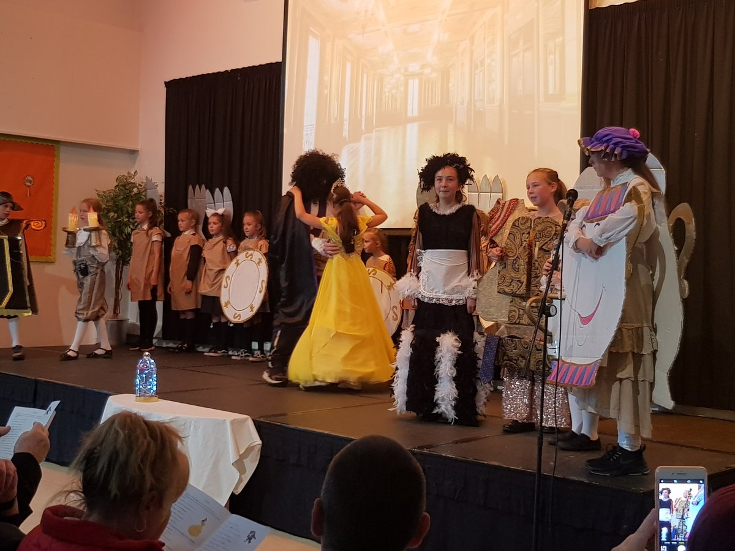
Play based activities for learners at P1 and P2 continues to promote independent, fun based learning for our younger learners whilst developing those important skills for learning, life and work. PEF funding has allowed the development of fun learning environments to support this learning.
Development of the young workforce skills specifically across expressive arts & technologies impressed the whole school community when P4-P7 performed Disney’s ‘Beauty & the Beast’. Learners behind the scenes worked with technology to ensure the show ran smoothly! In the words of our local councillor ‘… the confidence, commitment and dedication to the show were exemplary.’

Here is what we plan to improve next year.
Leadership of change
- Continue to build on improving pupil attendance
- Review Health & Well-Being with a focus on mental health
- Review whole school’s nurturing approach with all children, parents and staff through ‘All Behaviour is Communication training.
- Look at RRS, ECO and Global Citizenship within Growing Good Citizens

Learning teaching and assessment
- Continue Teacher Learning Communities to increase high quality learning and teaching experiences in every classroom
- Continue to promote play based learning to improve outcomes for learners at stages P1 and P2
- Review updated topics across Social Studies ensuring topics continue to be relevant to children’s lives within Drumchapel and the city of Glasgow.
- All teachers to become Apple Teachers
- More ipads will be purchased through PEF to enable all second level learners more access to use of digital technologies to support their learning.
- Review home learning and relevance to skills for life learning and work
- Implement new system of recording of achievements in and out of school.

Well-being, equality and inclusion
- Continue to engage identified learners and families in support programmes /activities funded by PEF to support achievement of learners and families: Prince William Award, The Spark Counselling service , 3D Drumchapel
- Continue to work with Family Learning Officer to create further opportunities for family engagement and learning
- Increase opportunities for outdoor learning across all classes.
Progress in improving outcomes for children in attainment and achievement

- Glasgow’s Improvement Challenge focus will be Numeracy& Maths [Universal & Targeted support from school’s Challenge Leader of Learning through Glasgow Counts strategies]
- Glasgow’s Improvement Challenge focus on Literacy for All will be continued[Embed strategies for Reading and Writing]

How can you find out more information about our school?
Please contact us directly if you require further information or if you wish to comment on the report.

The contact e-mail address is: headteacher@st-claresdrumchapel-pri.glasgow.sch.uk

Our telephone number is:0141-944-2554

Our school address is:15 Kilcloy Avenue, Drumchapel, G15 8RP

Further information is available in: newsletters, school handbook and the school website.
http://www.st-claresdrumchapel-pri.glasgow.sch.uk/

