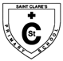
St Clare’s Primary School

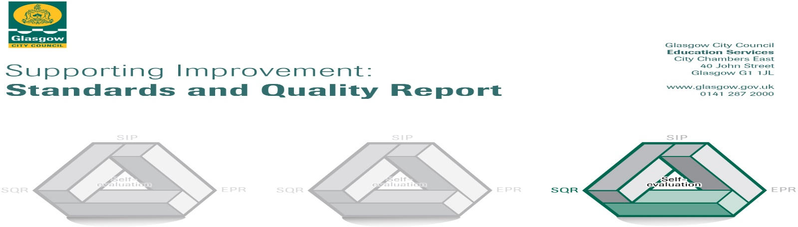

This summary report for 2018-2019 for parents/carers and partners outlines our achievements last session and our priorities for next session. We have taken forward our priorities as detailed in our school improvement plan. Through our processes of self-evaluation, we have identified how we can improve outcomes for our children, young people and families.

Our achievements and improvements this year:2018-2019
We would like to highlight the following improvements /achievements:

Almost all children experience positive, nurturing relationships within the Catholic ethos of St. Clare’s and there is a strong focus on children’s wellbeing across the school.
The vision, values and aims have been successfully reviewed this session giving everyone including partners and parish priest the opportunity to contribute.
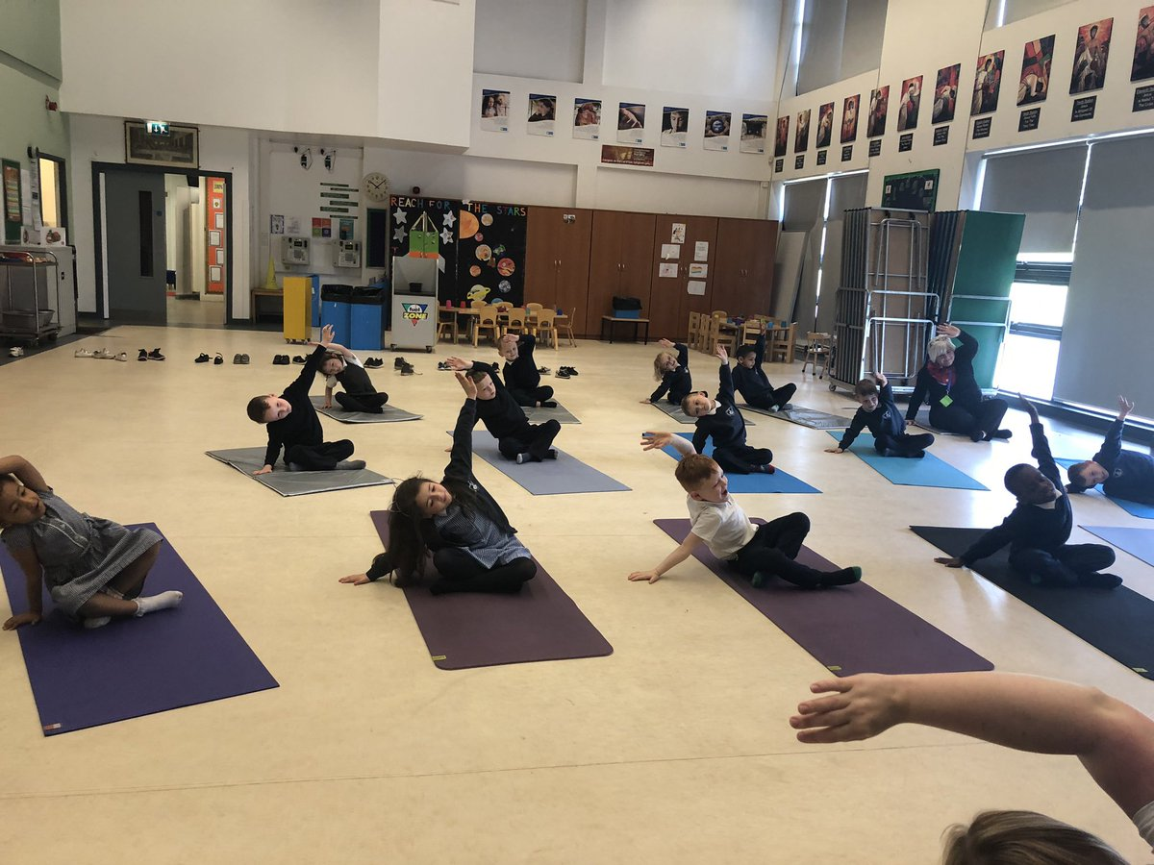
‘Believe and you will achieve’ was voted the most popular catchphrase by all to represent our vision statement. Our school motto ‘Altogether Every Day, Partnership in Every Way’ continues to support and promote our Catholic school values as well as a reminder to attend school every day. School attendance continues to improve; we will continue to build on this with your support.
Most of our P7 pupils have used what they have learned about the Gifts of the Holy Spirit in their lives across school, home and parish and achieved the Pope Francis Faith Award.
Staff are committed to our refreshed school vision and standards to ensure best practice and success for our learners and are actively taking forward Glasgow’s Improvement Challenge and school improvement priorities. Almost all teachers use Literacy for all and Glasgow counts frameworks effectively to engage, challenge and support learners across core areas.
Most staff are skilled in ensuring learner experiences are meaningful and matched to needs and interests of the learners through differentiation together with mixed ability groupings.
Overall attainment in Literacy & Numeracy is good and most children across whole school are on track with learning across core areas of Literacy & Numeracy. Raising attainment across the core areas is central to school plans for improvement.
As part of the Glasgow Improvement Challenge our ‘Challenge Leader of Learning’ has led staff through developments in the teaching and assessment of numeracy and provided targeted support for identified pupils in order to close gaps. Most learners across P1, P4 and P7 attained appropriate levels in Numeracy. Glasgow Counts numeracy strategies and interventions had a significant impact. All children targeted by this intervention made improvements towards closing the gaps in their mathematical knowledge. A group of children at second level made more than expected progress with almost all of them now being identified as on-track having previously been identified as off track. Across the school in most classes a significant trend in improved numeracy standardised test results was also evidenced.
In Listening & Talking most children across P1, P4 and P7 attained appropriate levels.
Most learners at P1 and P4 and the majority of learners at P7 attained appropriate levels in Reading.
Most learners at P1 and the majority of learners at P4 and P7attained appropriate levels in writing.
Playful Pedagogy in Primary 1 this session has improved pace of learning and challenge across curricular areas at early level. Significant increase in attainment across core areas of literacy and numeracy is evident also. Increased levels of independent learning by pupils and creativity in approaches to solving problems have been observed during play.
Pupil Equity Fund [PEF] is a valuable intervention which is supporting almost all of our children and families through universal and targeted approaches and has facilitated change leading to greater equity for all our learners and families. Additional staff, Spark counselling service and Skill force Prince William Award are just a few of the successful interventions provided by PEF.
Teachers and support staff have taken on a range of leadership roles and this ensures that best practice is shared across whole school.
As a result of the Tapestry programme and ‘Teacher Learner Communities’ there is a refreshed sustainable approach to ‘teachers supporting teachers’ in order to take forward improvements. All teaching staff and a few support members of staff, as a result, are engaging in activities which are leading to increased reflection, positive change and improved quality of teaching for learners. This is enhancing the school culture of supporting improvement whilst building the capacity of staff.
During visits to classes, almost all children were motivated and engaged in learning throughout literacy & numeracy lessons. Peer observations of learning and teaching in STEM lessons evidenced that in the majority of classes creative approaches across these subjects are being implemented.
Opportunities for outdoor learning are growing across most stages. Staff and children are now increasingly engaging in outdoor learning, using the beautiful green spaces of Drumchapel for both learning and development of well-being. The outdoor clothing purchased through Pupil Equity Funding is helping children embrace our Scottish weather!
P5 successfully achieved the John Muir Award for their efforts!

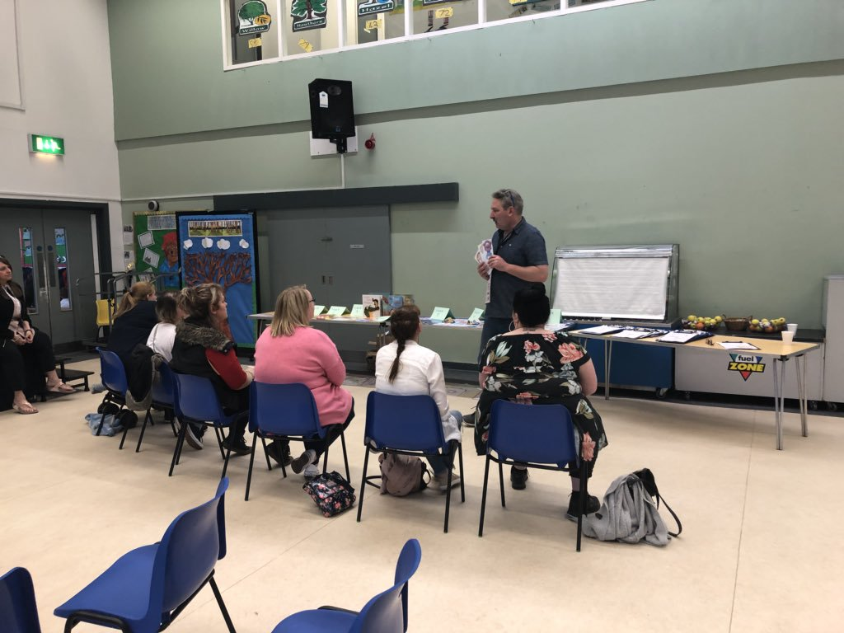
St.Clares has a Family Learning calendar of events which works successfully with the Family Learning Officer support to develop this further into a culture of family learning. The past academic year has seen the consolidation of work with the Feel Good Friday[FGF] group and the piloting of three very successful after school STEMtastic Family Sessions. The current group of parents who attend on a regular basis are being supported to become Family Learning Leaders – a role in which they will be supported to develop their skills and confidence to act as peer mentors to other parents in the school.
Stemtastic Family Sessions were planned and delivered by St.Clares teaching staff with support from the Family Learning Officers in the North West. An exciting and varied range of STEM related activities engaged and excited the pupils. As a result well over 100 parents and children attended each event . To date this has been one of the most successful pieces of family learning work run by the school in terms of numbers engagement and feedback received. In common with many family learning activities the success was in large part due to the time and commitment of the staff which for these sessions was considerable. The school is part of the STEM Inspired Communities project which is being developed with support from Education Scotland with the aim of taking a longitudinal approach to building STEM capital in the area. The STEMtastic family events were hugely helpful in arguing the case that local parents and children are interested in taking part in exciting learning opportunities together, for this this enthusiasm and interest to be challenged and developed resources need to be identified to support the planning and delivery of on-going work.
St Clare’s Parent Council continues to provide support in various ways including funding trips, sacramental gifts and gifting leavers’ presents.

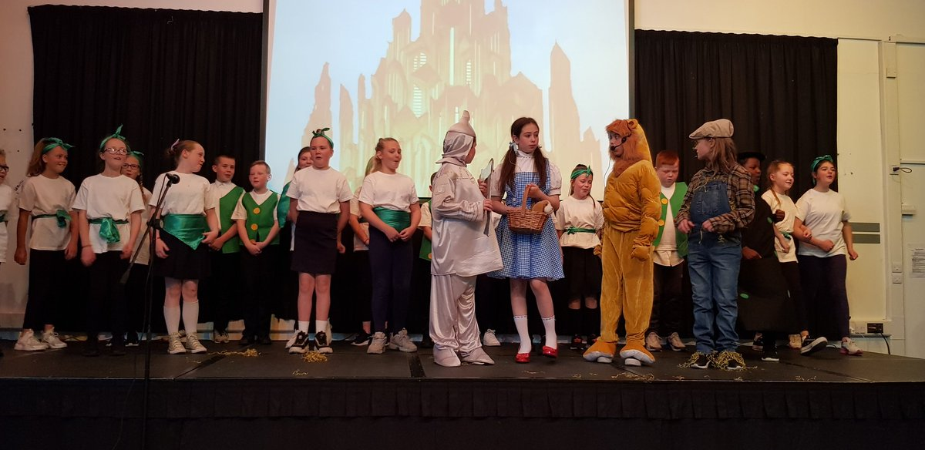
Development of work skills specifically across expressive arts & technologies continue to impress the school community when P4-P7 performed ‘The Wizard of Oz’ complete with green screen graphics! Pupils behind the scenes worked with technology and props to ensure the show ran smoothly! What a great way to end a great year of learning!

Here is what we plan to improve next year.
Leadership of change
- Curriculum development - Catholic Social Justice , Growing Good Citizens
& Global Citizenship
- Develop pupil leadership skills for all children through ‘Leader in Me’ training for staff.
- Developing the Young Workforce
Learning teaching and assessment
- Continue Teacher Learning Communities to ensure high quality learning and teaching experiences in every classroom
- Build on creative approaches within play pedagogy ensuring a challenging but achievable curriculum. Explore learning environments to support play and active learning across other departments [P2 & P3 and beyond]
- All teachers to become Apple Teachers

Well-being, equality and inclusion
- Continue to engage identified learners and families in support programmes /activities funded by
PEF
- Continue to work with Family Learning Officer to create further opportunities for family engagement and learning
- Continued focus on mental health
Progress in improving outcomes for children in attainment and achievement

- Glasgow’s Improvement Challenge focus will be Numeracy& Maths [Universal & Targeted support from school’s Challenge Leader of Learning through Glasgow Counts strategies]
- Glasgow’s Improvement Challenge focus on Literacy for All will be continued[Embed strategies for Listening & Talking Reading and Writing]

How can you find out more information about our school?
Please contact us directly if you require further information or if you wish to comment on the report.

The contact e-mail address is: headteacher@st-claresdrumchapel-pri.glasgow.sch.uk

Our telephone number is:0141-944-2554

Our school address is:15 Kilcloy Avenue, Drumchapel, G15 8RP

Further information is available in: newsletters, school handbook and the school website.
http://www.st-claresdrumchapel-pri.glasgow.sch.uk/

