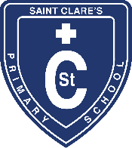
St Clare’s Primary School

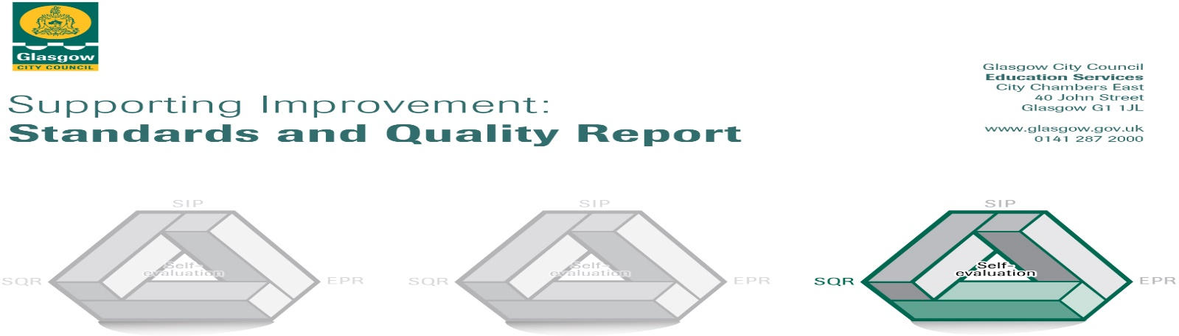
This summary report for 2020-2021 for parents/carers and partners outlines our priorities and achievements last session together with our priorities for next session.
Through our processes of self-evaluation including the views of our pupils, parents and partners, school data and monitoring of learners’ experiences, we have identified how we can improve outcomes for our children, young people and families.
Two lockdown periods during this challenging climate of Covid-19 resulted in a focus on planning not just for school improvement but also for school recovery, resilience and reconnection.
We are taking forward our priorities as detailed in our School Improvement Plan.
The next steps outlined at the end of the report will be incorporated into our planning for 2021-22

Our achievements and improvements this year:2020-2021
Priority 1: Plan and sustain a safe return to St. Clare’s Primary School and implement a Reconnecting, Recovery and Resilience Curriculum.
- A significant number of pupils safely attended school during lockdown, including children of key workers.
- In line with local and national guidance, our tailored Covid-19 risk assessments were, and still are, in place and regularly reviewed/updated to ensure that everyone in school feels safe.
- A robust approach to environmental cleaning and wearing of face masks by almost all staff helped prevent the spread of the virus. Feedback from a Health and Safety inspection was very positive about the school’s practice and procedures.
- When our Quality Improvement officer from the authority visited the school, she commented on the warm welcome she received from office staff when she arrived, as well as how robust the safety procedures were for visiting the school within the Covid-19 climate. [which hasn’t yet changed].

When everyone returned to school, St. Clare’s focus was then on Reconnecting and Recovery.
- Reconnecting and building inner wellbeing, relationships and resilience was a natural part of our nurturing school on our return to school.
- Changes to the school day timings supported our risk assessments. Staggered drop-off and pick-up times supported physical distancing between parents, staff and children. Continued class bubbles with limited numbers at lunchtimes were sustained in the lunch hall. Health and Safety information/guidance was continually shared with staff & parents via email, newsletters, our school website and via our Twitter account.
- HWB lessons were prioritised with a particular focus on mental health. We have various whole school programmes which support teaching staff to deliver this throughout the school.
- Spark Counselling Services supported a range of individuals from across different classes during lockdown.
- Our Family Support Worker, funded by the school’s Pupil Equity Fund, also provided an additional layer of support to families during this time in many ways; including supportive phone calls, signposting to services, foodbank referrals, wellbeing packs and Cash for Kids vouchers to name just a few.
Priority 2: Learning, Teaching and Assessment:
We learned important lessons from the first lockdown so when the second lockdown came we were better prepared to ensure pupils could continue learning from home!

Our ambitious vision continued to set a consistent focus on improvements in outcomes for all.
Guided by St. Clare’s Learning Lockdown Action plan and Home/ School Remote Learning Charter, we had a relentless aspiration for all pupils to access digital remote learning when schools were closed. We worked tirelessly to provide families with devices who didn’t have any and also to provide support with technical difficulties.
This Photo by Unknown Author is licensed under CC BY-SA-NC
As a result of staff planning together and supporting each other, children’s remote online learning experiences provided appropriate opportunities for new learning to facilitate progression.
This resulted in a great response where most pupils were engaged successfully in remote learning which clearly supported continued progression.
All teachers developed new digital skills to ensure that quality learning experiences and connection with pupils continued throughout this time. Most staff achieved Apple Teacher status.
A remote learning survey was sent out to parents to seek their feedback on how we were doing. Almost all parents who responded gave the school 4+ stars out of 5 for our communication, supportive approach to online learning and the quality of learning and feedback from teachers.
St. Clare’s was also one of the schools picked by the authority to engage in a telephone meeting with HMIe [Her Majesty’s Inspectors of Education] to discuss our school processes for the delivery of remote learning. This was very positive and our efforts recognised - we were doing the very best we could in a challenging time!
When our Quality Improvement officer visited the school later in the session, strengths and development areas were identified.
Strengths
- School Improvement Plan was looked at in depth and deemed a well written plan to take forward school priorities.
- The leadership of the Headteacher and SMT was noted as strong.
- Pupils are well-behaved and actively engaged in their learning.
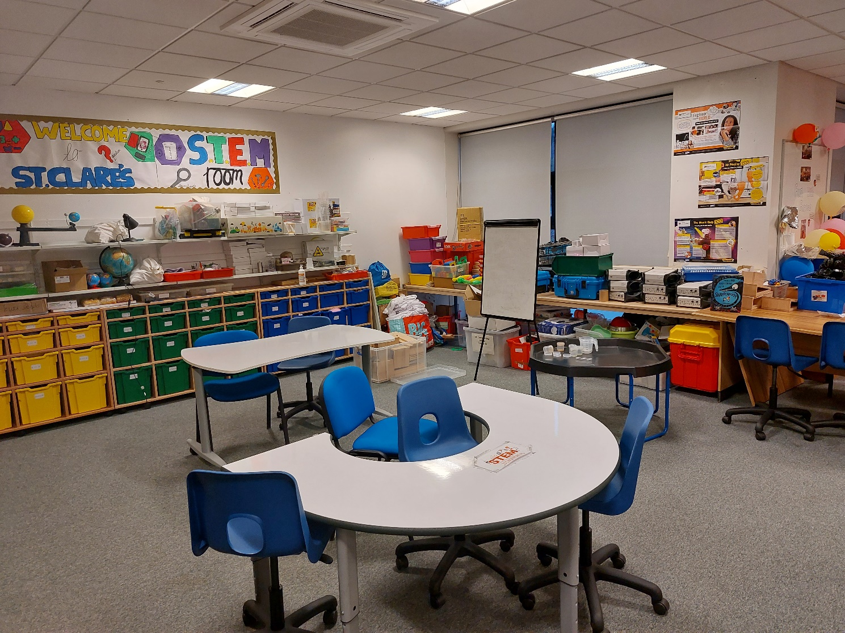
Areas for improvement
- Continue developing STEM room.
- Extending Play Pedagogy across middle school.

Priority 3: Raising Attainment and Achievement:

P1, P4 & P7 stages are at the end of Early, First and Second levels of Curriculum for Excellence. Numbers of learners on track with learning at these stages are recorded at the end of each school year and sent to the local authority.
Despite Covid 19, the overall attainment in Literacy & Numeracy last session was good. Most children across the whole school are on track with learning across the core areas of Listening & Talking, Reading & Numeracy. A majority of children are on track for Writing.
Compared to schools across the city, results for end of level stages P1, P4 and P7:
- St Clare’s pupils at P1, P4 & P7 pupils are performing equal to or higher than the city level results in Numeracy.
- P1 are performing higher in Listening & Talking
- P4 & P7 are performing higher in both Reading & Writing.
- Combined school results [P1, P4 and P7] are higher than city level results for Reading, Writing & Numeracy.
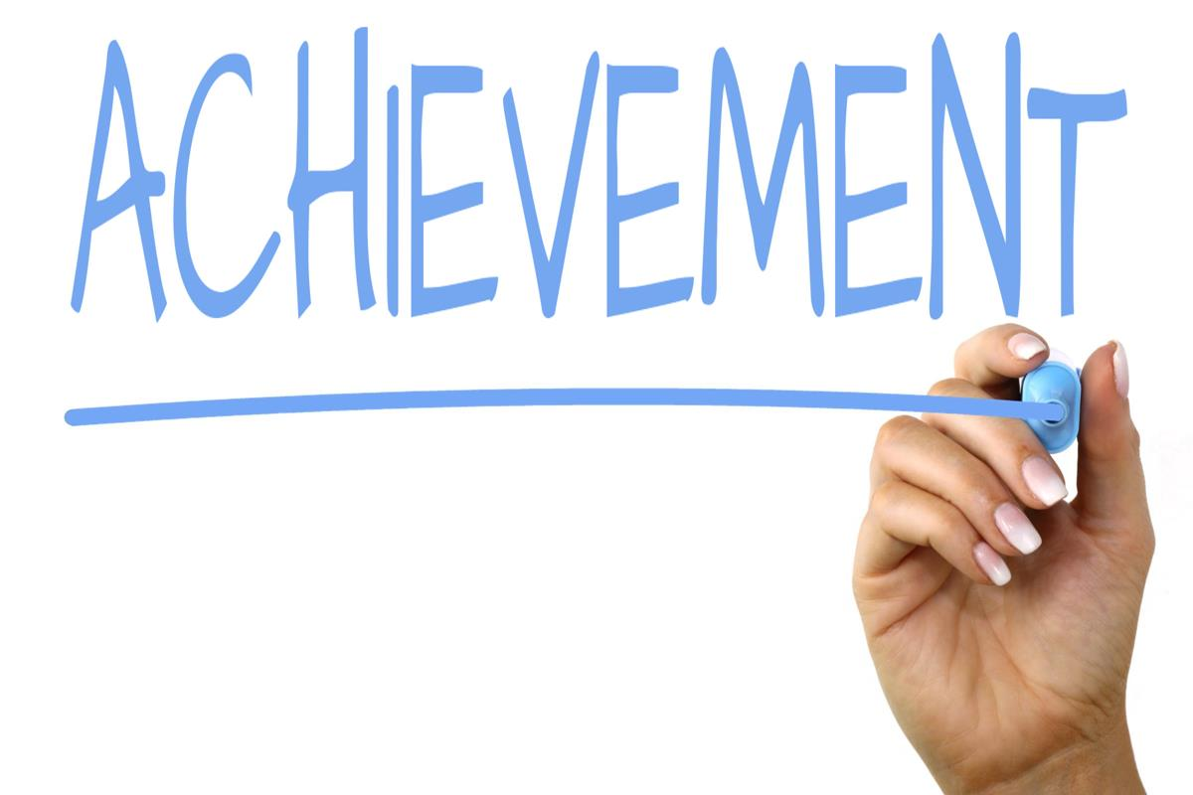
This Photo by Unknown Author is licensed under CC BY-SA

Here is what we plan to improve next year.
Priorities for development:
1: Raising Attainment and Achievement through Glasgow’s Improvement Challenge:
Continue to raise attainment in Literacy and Numeracy, with a specific focus on improving Talking & Listening and Writing attainment.
2: Wellbeing, equality and inclusion:
Continue to improve how we meet the needs of all children & young people and their families, particularly those with additional support needs.
We are working on this priority together with all the other schools across our St. Thomas Aquinas Learning Community.
3: Leadership:
We have a strong sense of leadership across our staff and we would like to empower pupils with the leadership and life skills that they need to thrive in the 21st century.
We want our pupils to be independent and successful learners who lead their own learning and develop a strong voice.
‘Leader in Me’ whole school programme is being implemented to support achievement of these goals.
Training for parents/carers to learn about this programme will be a part of this at some point in the future.
A wider achievement learning record is going to be launched soon to encourage learning across home, school and parish, which again will build on important life skills for our learners.

How can you find out more information about our school?
The contact e-mail address is: headteacher@st-claresdrumchapel-pri.glasgow.sch.uk

Our telephone number is: 0141-944-2554
Our school address is: 15 Kilcloy Avenue, Drumchapel, G15 8RP

Further information is available in: newsletters, school handbook and the school website.
http://www.st-claresdrumchapel-pri.glasgow.sch.uk/

