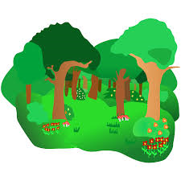 | Mrs McWatt/  Ms McFarlane  Forest Den Newsletter  Term 2 |  | 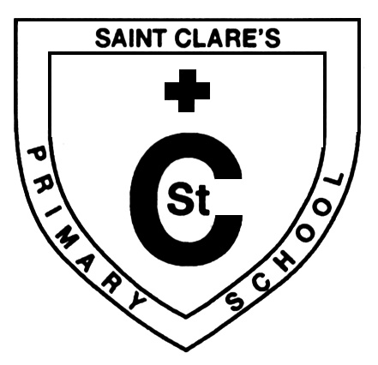
What we are learning about:
Pupil Choice  We make sure we always have time to read together. The children get to vote for a book of their choice that they wish to be read. The book with the most votes is read. The children love hearing stories read to them and discussing what’s happened in the story. They love to guess the ending and act out what is happening in the story. |  | Moby and Friends  We have been reading stories about Moby and his dog Woof. They bump into things as they don’t looking where they are going. Listening Lizzie and Looking Luke help Moby and Woof by showing them how to look at the person who is speaking and how to think about and talk about the same thing as the person speaking to them.  .
Emotion Talk
We continue to check in every day using ‘The Colour Monster’ to help us. We put our name on the name of the emotion we feel and describe the feeling. We have been learning that it is good to talk with our friends about how we are feeling and how our day has been. It can even cheer us up.

Things to remember…
Target Sheets

- Thank you for your continued support with the target sheets. Children have enjoyed talking about their ‘smileys’ and they have started moving their car along the race track when they achieve their targets. When they do 2 laps of the race track they can pick a prize!
- Remember the target sheets are popped into your child’s school bag every Thursday.

.
SeeSaw Group – The Forest Den  Thank you so much for your feedback and the engagement with SeeSaw every week. It is great to be able to communicate and discuss your child’s progress. Every Monday I show the children the SeeSaw Forest Den page. There is much excitement when they see photos of themselves on the big smart board! |  |  |  | 