****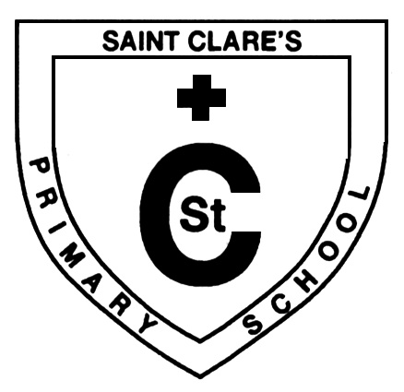‘Altogether Every Day,

Partnership in Every Way’

**February 2020 Updates**

Dear Parent/Carer,

It’s been a busy month in St. Clare’s with lots happening inside and out of the classroom. Glasgow University staff recently visited us to see how our pupils in P1-3 learn through play, whilst Carol from Boozebusters has been exploring the dangers of alcohol and peer pressure with pupils in the upper school.

All pupils have reflected on safe use of the internet as part of Internet Safety Day and outdoors, our school garden is taking shape nicely and will be ready in time for spring. Well done to those of you participating in the Couch to 5k programme and it has been lovely to see parents/carers who have managed to attend our parenting classes and nurture drop-in sessions.

Ms McGuinness has recently undergone ankle surgery and is now recovering. I’m sure you will join our pupils and staff in wishing her a speedy recovery.

As always, please do not hesitate to contact the school if we can be of assistance and thank you for your continued support.

**Mr Muir.**

Martin Muir (Deputy Headteacher)



In the interest of health and safety, Glasgow City Council operates a no dogs (except guide dogs) on school grounds policy.

**Please adhere to this.**





This year World Book Day will take place on **Thursday 5th March**. Mrs Morrison and the staff are working hard to make the day a success.

Please follow the day’s events on Twitter using the handle **@StClaresDrum**





**Feel Good Fridays**

Our Feel Good Friday sessions take place on **Friday mornings between 9am-10am.**

Come along and meet other parents/carers over a cuppa and some biscuits.

These informal sessions offer you the opportunity to find out what’s happening in the local community and further afield.

Hope to see you there!

**CommuniTeas**

You are invited to our weekly drop-in CommuniTea every Wednesday between 1:30pm-3:00pm. Come along and meet other parents/carers over a cuppa and learn about what’s on in the community of Drumchapel.

***February Programme:***

Wednesday 19th February – News from 3D Drumchapel.

Wednesday 26th February – Mind & Draw



**Have a chat with our Family Support Worker**

I am delighted to advise that Michelle, our Family Support Worker from 3D Drumchapel will continue to work with our families from now, through the summer holidays and into next session.

Michelle is in school every Tuesday & Wednesday. She is available to all families who require support with any of the following:

* Benefits
* Positive parenting
* 1-1 support
* Support within the home
* Signposting to services
* School holiday activities
* Attendance at appointments
* And many other issues or concerns.

Please phone the school or stop by to make contact with Michelle for more information.

C:\Users\mm2031753\AppData\Local\Microsoft\Windows\Temporary Internet Files\Content.IE5\NT2CSRI7\blockpage[1].gif

**St.Laurence’s Sacramental Preparation and Celebrations**

* **Sacrament of Reconciliation @ 7pm Wednesday March 11th**
* **Sacrament of First Holy Communion @ 11am on Saturday May 16th**
* **Sacrament of Confirmation @ 7pm Tuesday 12th May**

**Meeting for Parents**

**Tuesday February 18th 2.30pm @ St.Clare’s Primary**





**Pupil Equity Fund Updates**

Some of our funding will be used to secure the services of Michelle, our Family Support Worker throughout the summer holidays and into session 2020/21.

All pupils are currently participating in activities using our on-loan 3D printer. These activities promote a variety of skills including creative thinking, solving real-life problems and team work. We are now looking at the possibility of purchasing our very own 3D printer for the long-term benefit of our pupils.

**More updates coming soon…**

**Follow us on Twitter**

**St Clare’s has an active Twitter page which is a great way for us to share with you the goings on in school throughout the year.**

**Please follow @StClaresDrum**

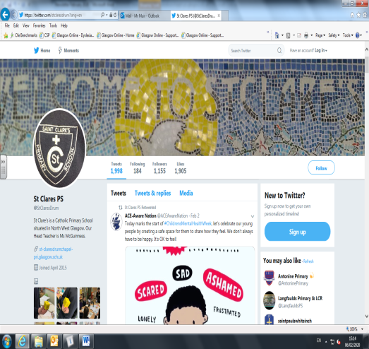

Kindest Regards,

**Martin Muir**

**Acting Headteacher**