****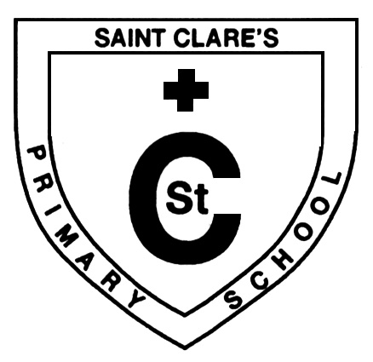‘Altogether Every Day,

Partnership in Every Way’

**January 2020 Updates**



Dear Parent/Carer,

Happy New Year to you and welcome back to Term 3 of this session. This is always an extremely busy and hardworking term. We have started in a positive way with the children settling back into their working routines and our plans for the rest of the session are developing well. That said, Ms McGuinness’ mother sadly passed away during the Christmas holiday and Mrs Morrison’s father passed away on Thursday. I am sure that they will both take comfort in knowing that the whole school community is keeping them and their families in their thoughts and prayers at this very difficult time.

Martin Muir (Deputy Headteacher)

**Head Lice**

The start of the new term seems a good time to remind parents/carers of the importance of checking your child’s hair regularly. School nurses no longer do this and it is not authority policy to send out letters when a child is reported to have head lice. The advice remains the same, immediate treatment by lotion recommended by a pharmacist, then automatic repeat treatment 7 days later. Please be vigilant.



**School Garden**

You may have noticed that our school garden is in the process of being transformed. High quality outdoor learning experiences are proven to develop a wide variety of key skills, qualities and attributes such as communication, collaborative working, self-awareness and confidence. I am sure that once complete, our new and improved school garden will continue to provide our young people with valuable learning experiences.

**Mid-term Holidays**

**Friday 7th February 2020 (In-Service day)**

**Monday 10th February 2020**

**Tuesday 11th February 2020**

**Wednesday 12th February 2020 (In-Service day)**

The school re opens for the children **at 9.00am on** **Thursday 13th February 2020.**





**Feel Good Fridays**

A number of our parents/carers attend our Feel Good Friday sessions between 9:15-10:00am in our gym hall and I would urge more of you to come along and see what’s on offer. There is an exciting programme of events planned for this term and each session provides an informal opportunity to meet other parents/carers over a tea/coffee and some biscuits. Below is a flavour of what’s coming up:

17/01 Connecting to Your Community with *Thriving Places*/*Aspiring Communities*

24/01 Poetry and Porridge with *Axis Health Hubs*

31/01 Goal Setting for 2020 with *Kelvin College*

14/02 Things to Love About Yourself/Pamper Day with Glasgow Kelvin College

21/02 Laughter Yoga – tbc.

28/02 Connecting to Your Community….and much more!



.

.

**Film Education**

Thanks to a successful funding application made by Mrs McWatt, pupils across the school will have exciting opportunities to work alongside staff from Creative Scotland. In doing so, our young people will develop their knowledge and skills relating to film literacy. This includes using various tools, devices, apps, pictures, moving images and sounds. Pupils will apply their new learning to create a short film about Global Goals. I look forward to seeing what the children come up with!

C:\Users\mm2031753\AppData\Local\Microsoft\Windows\Temporary Internet Files\Content.IE5\NT2CSRI7\blockpage[1].gif

**St.Laurence’sSacramental Preparation and Celebrations**

* **Sacrament of Reconciliation @ 7pm Wednesday March 11th**

**Meeting for Parents**

**Tuesday January 7th 2.30pm @ St.Clare’s Primary**

* **Sacrament of First Holy Communion 11am on Saturday May 16th**

**Meeting for Parents**

**Tuesday 4th February 2.30pm @ St.Clare’s Primary**

* **Sacrament of Confirmation @ 7pm Tuesday 12th May**

**Meeting for Parents**

**Tuesday February 18th 2.30pm @ St.Clare’s Primary**



**C:\Program Files (x86)\Microsoft Office\MEDIA\CAGCAT10\j0222017.wmf**

**Pupil Equity Fund Updates**

* We have now purchased a Family Support worker from 3D Drumchapel-Michelle Clark.

She’s most welcome and will be a great source of support for our school community

**More updates coming soon…**

School Holiday Reminder

|  |  |
| --- | --- |
| Inservice Day 4 [Additional In-Service Day] | Friday November 29th 2019 |
| Christmas/New Year (Thursday 19th December school closes at 2:30pm) | Friday 20th December 2019 to Friday 3rd January 2020(inclusive) |
| Return to School | Monday 6th January 2020 |

Kindest Regards,

**Martin Muir**

**Deputy Headteacher**

**St. Clare's Primary School**