 | Miss Gradini  Primary 1a  Term 2 Newsletter |  |  | 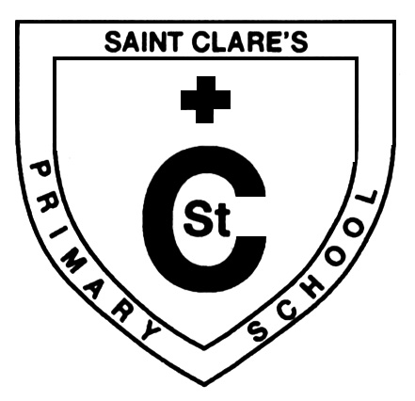
What we are learning about:
Maths  We will continue to count, read, order, write and recognise numbers 0-20. Children will learn number bonds 0-10. We will also be learning about money and recognising different coins. We are also learning about 3D shapes and their properties. Children will also continue to spot 3d shapes during their outdoor learning sessions. |  | Language  We will continue to learn all about sound. We will continue to read in class and learn to summarise a story. We will continue to focus on the key components of a book – title, spine, and blurb. We are listening for different sounds in words and beginning to blend our sounds. We are learning to create cvc words (e.g. cat, pin, leg) independently. Please encourage your child to continue this at home too.
Health and Wellbeing
We are learning about what makes a good friend and how we can help others; this will be a key focus during Anti Bulling Week. We are also learning about how to look after ourselves.

Things to remember…

Sounds: We are learning new sounds every week; if your child spots an object that starts with the particular sound that we are learning, encourage a discussion about that sound.

PE: Our PE days are Tuesday and Friday. Please ensure that your child has a hooded jacket with them and no jewellery otherwise they will not be able to take part.

Home Learning: Home learning is set monthly for P1. Please complete this with your child as well as practise their new sounds and stage words to help reinforce the great work in class. Please ensure you are reading with your child daily.

RE.  The children will be listening to and responding to Bible stories. The children will learn the Hail Mary prayer and The Our Father prayer. |  |  | 