 | Miss Ferguson  Primary 1b  Term 2 Newsletter |  |  | 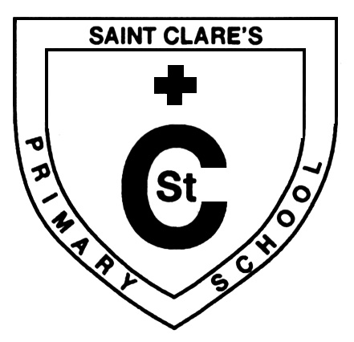
What we are learning about:
Maths  We are learning to recognise 2D and 3D shapes and discuss their properties. We are also exploring everyday 3D shapes that we may see at home or in school. We are exploring money and discussing what we use it for. We are learning to recognise coins and discuss what coins we may need to pay for an item on a shopping list. We have started exploring data handling, gathering objects and information and coming to conclusions about our findings. |  | Language  We are learning our initial sounds and are able to recognise letters and the sounds they make. We are learning to blend our sounds together to make CVC words and continuing to look at rhyming words. We are listening for different sounds within words, and if the sound appears in the beginning, middle or end. We are continuing to look at the main features of a book and using our prediction skills to guess what will happen in a story before reading it. We will shortly be looking at recipe writing and how detailed we need to be when giving instructions.
Health and Wellbeing
We are learning about feelings; recognising how things make us feel and understanding how we can make other people feel good. We are learning that there are people we can go to if we are feeling sad, and that these feelings are temporary. We are also learning about physical exercise and keeping ourselves healthy. We take part in outdoor PE games, walking and yoga.

Things to remember…

Sounds: We are learning new sounds every week; a good game to play is ‘Eye Spy’ with sounds to help develop awareness of sounds within words.

PE: Our PE will continue to be outdoors for the time being, please ensure that your child is dressed appropriately for the weather as move into the season of Winter. Our PE days are Wednesday and Thursday.

Home Learning: Your child will receive a home learning pack that contains sound cards and word lists. Please use the cards to make the words as this will help your child to read and write. We will continue to use SeeSaw as our main tool for home learning and hard copies can be given out if needed.

Religious Education The children are continuing to listen and respond to Bible stories. We will be looking closely at characters within the Bible and using Expressive Arts techniques to explore how they may have acted or felt. |  |  | 