Miss Murray
Primary 2
Term 2 Newsletter
Maths  Mental Maths: We will be focusing on sequencing numbers forwards and backwards to 100, creating number stories for any given number between 0-100 and working through various addition and subtraction calculations.  Mathematics: We have been focusing on place value, 3D shape patterns, working with money and time.  Developing the Young Workforce: We will be looking at applying numeracy into our daily lives and will continue to do so. |  | Language  Reading: We will be working on developing fluency, comprehension and sounding out difficult words using a range of texts.  Digital Literacy: We have used exciting and engaging digital literacy books as a stimulus for our writing and will continue to do so.  Writing: We will focus on descriptive language and punctuation, and how they make our writing more interesting and sophisticated and will continue to do so.
Health and Wellbeing
We are learning about the benefits of meditation and looking at other strategies to help us feel calm and less anxious in an uncertain time. We will be looking at how to plan for choices and changes. We will also be looking at how to remain healthy and how our choice in what we consume can help with this.
Religious Education
We will be focusing on appreciating and understanding other religions and comparing the differences and similarities with our own.

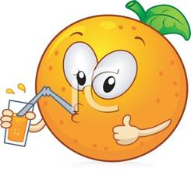 | Things to remember…  - Healthy snacks and packed lunches  - Primary 2 will continue to participate in outdoor learning. There are outdoor jackets and wellington boots if children do not have their own.  - Children will receive their homework each Tuesday on SeeSaw for completion on the Friday. Grids are uploaded to provide choice and enjoyment for pupils. Please complete at least two tasks for both Literacy and Numeracy.  Primary 2 will have P.E on Wednesdays and Thursdays outdoors as often as possible.
Our Topic:  This term our topic will be Transport. We will be exploring this topic through each curricular area with special attention given to STEM subjects. |  |  | 