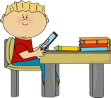 | Miss Currie  Primary 3/2  Term 2 Newsletter |  |  | 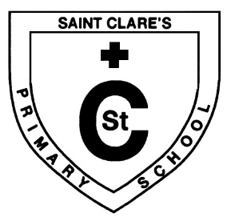
What we are learning about:
Maths  Mental Maths: We will be focusing on ordering numbers, addition and subtraction.  Mathematics: We will be working on STEM activities and fractions.  It would be helpful to practise addition and subtraction with your child at home. |  | Language  Reading: We will be developing our reciprocal reading strategies of summarising and clarification.  Writing: We will continue to develop our skills relating to sentence structure and will learn to use adjectives and descriptive phrases. We will also be developing our punctuation skills.
Health and Wellbeing
We will be learning about emotions and building good friendships. We will also be learning more about ways to keep healthy both physically and mentally.
Religious Education
We will be learning about different prayers and the colours within the Liturgical Calendar.

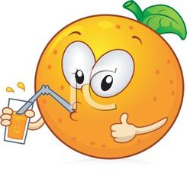 | Things to remember…  Healthy Snacks and Packed lunches  We have been participating in lots of outdoor learning. Please make sure children are dressed appropriately for the weather. There are outdoor learning jackets and wellington boots available in school.  Homework has been launched with an active learning approach. All pupils have been provided with a learning pack of paper, pencils and physical copies of both the Literacy and Numeracy homework walls. Each child should aim to complete two Literacy and two Numeracy activities per week and upload to SeeSaw if possible. If unable to do so, learners should bring in their homework on Friday to receive feedback.
Our Topic:
This term our topic has will be Victorian Schools in Glasgow. We have explored our health and well-being through a variety of activities.
Also this term, we will be exploring rights of children, comparing life in the past and present.

