 | Mr Devaney  Primary 4/3  Term 2 Newsletter |  | 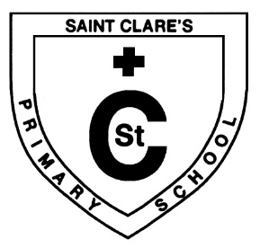
What we are learning about:
Maths  Mental Maths: We are focusing on doubling and halving numbers.  Mathematics: We have focused on place value, 3D and 2D shape, time and problem solving.  It would be helpful to practise counting up in 2’s, 4’s and 5’s with your child at home. |  | Language  Reading: This term we are focusing on our reciprocal reading skill of summarizing through our whole class reading of The Christmasaurus by Tom Fletch.  Writing: This term we have been working on our use of adjectives in writing to develop our descriptions of character and setting.
Physical Education
This term we are lucky to have had the input of PE Specialist Mrs Nichol who has worked with the class on our running skills. With updated guidance, PE now can be moved indoors however we will continue to have our PE outside on a Wednesday and Thursday weather permitting.

Religious Education
In RE this term, we will be looking at other faiths, focusing on Sikhism whilst remembering the holy souls throughout the month of November. We will also be raising money for the homeless in Glasgow by participating in Glasgow University’s Walk to the Vatican. If you would like to donate to the cause the link is below.
https://www.justgiving.com/crowdfunding/vaticanvirtualwalk?utm_term=3NR2rmZWD

Things to remember…
Healthy Snacks and Packed lunches

Just a reminder that homework is due on Friday in person if not uploaded via SeeSaw. SeeSaw is used to upload our new active learning homework every few weeks as well as having the spelling works uploaded on a Monday afternoon for the week ahead.
Our Topic:  This term we will be investigating “Drumchapel before Drumchapel” whilst participating in a host of focus weeks on Reading, Anti-Bullying and Inter-Faith amongst others. |  |  | 