 |  | Miss Diamond  Primary 5/4  Term 2 Newsletter |  | 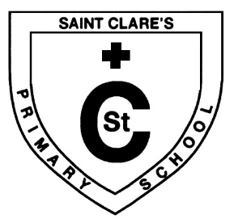
What we are learning about:
Maths  Mental Maths: We will be continuing to focus on multiplication and division this term.  Mathematics: We will be starting this term off with measurement. We will be learning to use a range of instruments to estimate and compare length, capacity, weight and area. We will also be telling the time in both 12 and 24hour time.  It would be helpful to practise the times tables with your child to help them build their confidence in recalling the table facts. |  |  | Language  Reading: We will be working on developing our fluency and expression whilst reading. We will continue to use a range of reading strategies to help us engage and understand a text.  Writing: This term we will be looking at features of fiction and non-fiction texts and will use these in our writing. We will also be creating character descriptions and developing our report writing. Throughout this term we will be continuing to work on sentence structure and VCOP.
Health and Wellbeing: This term we will be learning about ways to keep healthy; both physically and mentally. We will be learning to accept that it is ok to have different ideas and opinions from each other and that we must be respectful of these.

Religious Education: Primary 5s will be preparing for their First Holy Communion this term. We will be remembering loved ones during the month of All Souls and learning about God’s role in helping people through difficult times. We will also learn about Advent and revisiting the story of the Nativity.

Things to remember…

- Healthy Snacks and Packed lunches.

- Outdoor learning: Outdoor learning will continue to be a big focus this term so ensure your child comes to school suitably prepared. Wellington boots and/or other suitable footwear can be brought in and stored in the classroom. PE days are Mondays and Tuesdays.

- Please check homework every night and sign your child’s jotter. Homework will continue to be given out on Monday and should be returned on Friday.

