 |  | Miss Ní Nualláin  Primary 5  Term 2 Newsletter |  |  | 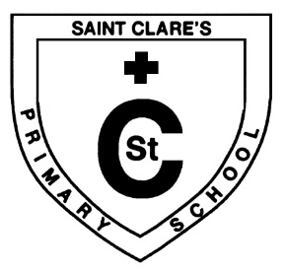
What we have learnt about:
Maths  Mental Maths: We have been working on adding and subtracting up to 4 digits quickly and efficiently.  We have also worked on our times tables through various games and activities. We will start looking at division.  Mathematics:  This term we will focus on the inverse operation and fractions as well as budgeting and solving money problems. We will also look at measure and collecting and displaying data. |  |  | Language  Reading:  We will be focusing on reading with expression, as well as using before, during and after strategies such as prediction and summarising.  Writing:  Our Big Writing areas of focus this term are information reports, character and persuasive writing. The children will be given ‘talking homework’ the night before to research and discuss the topic with an adult at home as preparation for their writing task.
Health and Wellbeing
We have been focusing on friendship, kindness and respect. We have Friendship Friday coming up this Friday 13th November too!

Religious Education
We have been preparing in class for our First Holy Communion, looking at the story of God’s Creation, The Passover and Exodus, The Lord’s Supper and The Holy Eucharist.

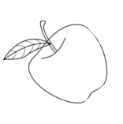  Things to remember… | - Try to provide healthy snacks and packed lunches where possible.  - PE is on now on Monday and Wednesday and this can now take place indoors in the gym hall. Sessions will continue to be outdoors weather-permitting.  - Homework – Children have spelling as well as Literacy/Numeracy tasks each week. Please check and sign your child’s work every week. They can submit this work on SeeSaw if they wish.  - Outdoor learning – We have continued with outdoor learning sessions so please ensure your child has suitable footwear and outerwear every day, as we move into winter.
Our Topic…  Our topic this term is Mary Queen of Scots so we have been learning her story, looking at her family tree and creating some artwork! |  |  |  | - It is Anti-Bullying Week 16-20 November.  - Book Week Scotland takes place 16-22 November.  - It is also Scottish Interfaith Week 8-15 November.

