 | Miss Young  Primary 6  Term2 Newsletter |  | 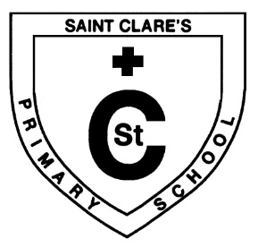
What we are learning about:
Maths  Mental Maths: We will continue to focus on mental maths strategies.  Mathematics:  We are focusing on time, inverse operations, and multiplication & division. Could you please check that your child is able to access Showbie as this will be our main point of access for home learning. |  | Language  Reading: Reading has been a big focus this term. We have taken full advantage of daily reading for enjoyment.  Writing: We are focusing on creating texts and describing character, setting and events. The class are developing their skills relating to tools for writing.
Health and Wellbeing
We continue to explore our emotions and our responsibilities. This term the class are developing their communication skills in order to resolve issues.
Religious Education
We have been learning about the life of Jesus Christ and the Exodus story. We have also been learning to pray the Rosary.

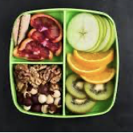 | Things to remember…  Healthy Snacks and Packed lunches  This term we shall continue to keep focused on healthy eating and promoting an active lifestyle.  Homework will continue to be handed out on a Monday and we will aim to have the IPads taken home in order to have work completed and feedback given via Showbie.  Please get in touch with me if there are any issues.
Our Topic:  Our topic this term is Glasgow and the Slave Trade. We are exploring how Glasgow has financially benefited from the Slave Trade and how Slavery impacted on the African communities that slaves were taken from. |  |  |  | 