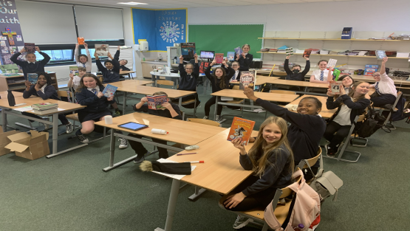 |  | Mr Logan  Primary 7  Term 2 Newsletter |  |  | 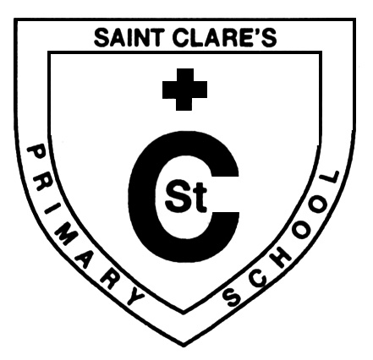
What we are learning about:
Maths  This term we will be focusing on :  - Addition, subtraction, multiplication and division strategies – we revisit these often to build pupil confidence.  - Shape, measure and movement, including symmetry, area, perimeter and nets of 3D shapes.  - Negative numbers, including through the real-life context of temperature, money, bank accounts and overdrafts.  - Data handling, and the various ways in which data can be presented.  Maths counting routines and home learning has been focused on knowledge of times tables, which is essential for pupil confidence. |  |  | Language  Reading: We are focusing on literal, inferential and evaluative questions and strategies that can help us answer them. We will be using the reading app Giglets in class, and children are, as always, encouraged to read for pleasure at home. Our class novel this term is ‘A Murder Most Unladylike’ by Robin Stevens, who will be hosting a live webinar just for us later in the term!  Writing: We will continue to focus on good, effective examples of vocabulary, connectives, openers and punctuation, and will be carrying out a month long characterisation study through our WW2 topic.  Talking and Listening: This term we will continue to explore ‘Group Talk’ lessons, which highlight effective skills when holding a debate with others.
Health and Wellbeing
In term 2, we will be investigating harmful substances and how we can live a healthy lifestyle. We will also focus on building mental resilience and strategies to cope in stressful situations.
Religious Education
As we move into the Christmas season, we will be looking at the significance of Advent for Christians and will also be learning about other significant world religions.

Things to remember: PE — Our PE days are Tuesday and Friday and pupils will now take part in lessons both outside and inside. Pupils are encouraged to wear comfortable leggings/trousers whilst maintaining the school uniform in the form of a shirt and tie or polo shirt. If possible, gym trainers can be brought in on this day as well. Please remember not to wear jewellery or watches in school on a Tuesday or Friday.
Homework Literacy and Numeracy homework will be issued weekly, posted in the relevant folder on Showbie and reflecting the learning in class. Spelling words will also be issued weekly as well as talking homework which will support Big Writing.
Our Topic… Our topic for this term is WW2. We will be looking at the history of war, investigating major characters and significant events. We will be exploring our topic through Art, Drama and digital technology. Pupils will have a home learning task to complete this term on their iPads which will be related to the war. We will also be using the new school radio equipment to broadcast our work! |  |  |  | 